Exporter’s Company Name
Address. ABN, Phone, Email
EXPORT CONTAINER VGM DECLARATION
Vessel /Voyage: ___________________
Beyond Borders Express Booking / Carrier Booking Ref: _________________
Container Number: __________________
Seal No: __________ Type: 45G1 (Please check the container back to find out details)
Goods Gross Weight: __________ （1） Container Tare Weight: ______________ （2）
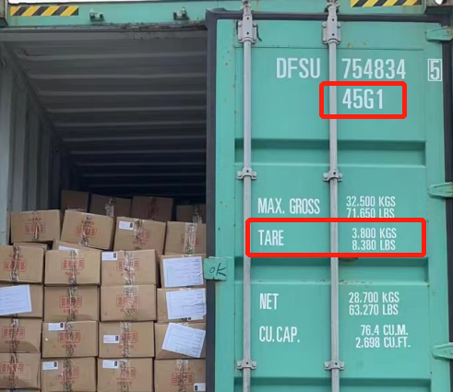
TOTAL Declared VGM: ___________KG *（1）+ (2)
(Above as a sample, picture does not need to be provided)
Exporter’s Declaration:
I, ________, on behalf of the shipper: _____________ declare that the gross mass of the subjected container(s) has/have been verified by using (please circle)
Method 1: Weighing the Packed Container (Certified Weight bridge, etc.), or
Method 2: Weigh all packages and cargo items, including pallets, and add the container's tare mass.

I understand that the accuracy of the VGM (Verified Gross Mass) obtained for a container is solely the responsibility of the shipper and can be monitored by the relevant regulatory authority. Any misleading or incorrect declaration will delay container loading and may result in a penalty of up to AUD 500/container + GST.
Name of Approved representative*: Position: Export Manager

Signature of approved representative* ___________________

Mobile phone*: ________________ (emergency contact number)
E-mail: ______________________
Date Of Declaration*: _________________________

